Welcome to the second segment of Getting Started with Google Suite. By the end of this segment you should be able to explain how to access Google Drive without going through a company portal, describe Google Drives three main functions, and list a few applications that can be accessed through Google Drive.

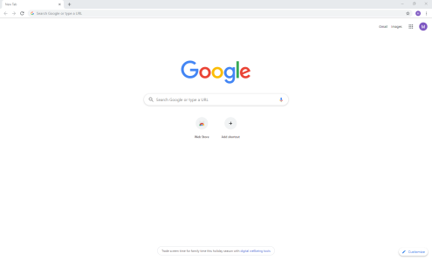**How to Access Google Drive without Going through Portal.**

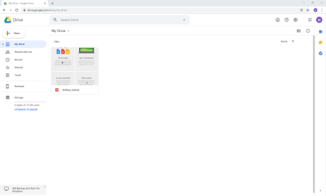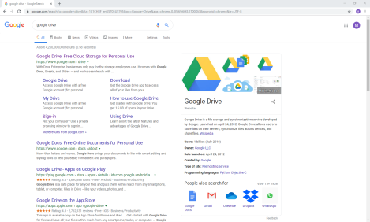Most corporations and schools will have a landing portal that contains the major applications used constantly. If you ever need to access Google Drive without going through the portal, possibly when using your home computer, it’s relatively simple to do. First open Chrome and make sure that the correct account is logged in, not your personal one. Then in the address bar type “Google Drive” and hit enter. Click on the “Google Drive” that pops up in the searchand it will take you to your Drive.

**What is Google Drives Function?**

Google Drive has three main functions.

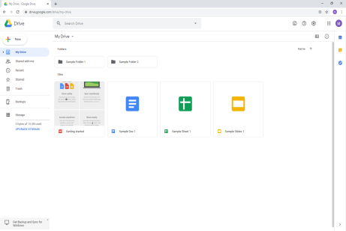The first is what I call the filling cabinet function. It is where anything created within the Google Suite can be accessed. This is an improvement to trying to access the items through their respective applications because it will show sheets, slides, documents, you get the idea. Where if you are trying to access them through the respective applications you would need a tab open for each different item you wanted to access. Also just like a filing cabinet can be organized Google Drive can have folders created for specific content to be put in so it’s not just a messy collection of files. To create folders you can either click the “new” then “folder” or right click and then click “new folder.” Adding files to a folder is a simple as dragging it to the folder and then releasing it. You can also just click into the folder and create the new file there.

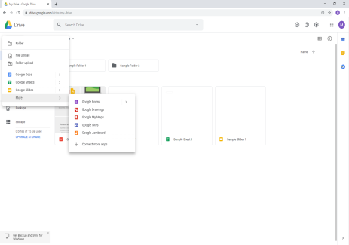The second function of Google Drive is as a launch pad for the other Google applications. From the “New” button you can access all the Google applications that allow you to create content. The Grid pattern in the top right corner will also allow you to access other Google applications.

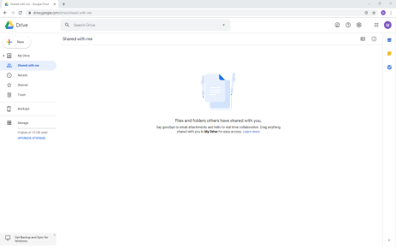The third function of Google Drive is that it allows you to access any file or folder that someone has shared with you without having to go through the email link just by clicking on “shared with me” on the left hand side of the screen. This can be very useful if you have deleted the email in an attempt to keep your inbox tidy.

**What can be accessed from Google Drive?**

Let’s spend a little longer looking at what can be accessed from Google Drive and where you would need to click to be able to access it.

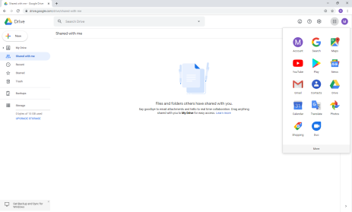Clicking on the “New” button would allow you to create a Google Docs, Google Sheets, Google Slides, Google Forms, Google Drawings, Google My Maps, Google Sites, or GoogleJamboard. The main ones you will probably find yourself using the most are Google Doc, Sheets, Slides, and Forms.

Clicking on grid in the top right corner will allow you to access the non-creative Google applications such as Google Search, Google Maps, Youtube, Google Play Store, Google News, Gmail, Google Contacts, Google Drive, Google Calendar, Google Translate, Google Photos, Google Shopping, and Duo. Clicking on the “More” button will allow you to access a few more applications.

This concludes this segment of Getting Started with Google Suite. By now you should be able to explain how to access Google Drive without going through a company portal, describe Google Drives three main functions, and list a few applications that can be accessed through Google Drive.

Next up is the segment that explores Google Documents.